

**GUIDE FOR CONTENT OF A**

**STAKEHOLDER ENGAGEMENT PLAN**

**2014-11-02**

DOCUMENT CONTROL

|  |  |  |  |
| --- | --- | --- | --- |
| **Reference No.** | Form A13 | | |
| **Document Title** | Guide for Content of a Stakeholder Engagement Plan | | |
| **Document Author** | M/S Grontmij | | |
| **Reviewed by** | Management | | |
| **Approved By** | Management | | |
| **Document Version** | 2 | **Document Status** | FINAL |
| **Date Released** | 2014-11-02 | | |
| **File Name** | 20141102_GuideContentStakeholderEngagementPlan.docx | | |

DOCUMENT CHANGE HISTORY

|  |  |  |  |
| --- | --- | --- | --- |
| **Version** | **Date** | **Author** | **Description** |
| **1** | 2014-11-02 | M/S Grontmij | Initial release |
| **1.1** | 2023-03-30 | Anselm Olweny | Updated ERA Logo  Inserted Document Control Page |

1. **Cover page**

*Including logo, project title, name of developer, name of consultant*

1. **Contact details**

*Email, phone nr. etc. of contact person*

1. **Table of Contents**
2. **Introduction**
   1. Background

*(For example stating that this is a living document to be reviewed and updated as the project progresses.)*

* 1. Objectives of the Plan

*(For example “to describe the methods, procedures and actions undertaken by (developer) to inform stakeholders in a timely manner of the potential impacts of the project”)*

* 1. Scope of the Plan

1.3.1 Overview of the Stakeholder Engagement Plan structure

1.3.2 How the plan will be disseminated

1. **methodology**

*General description of the methodology used, and the qualifications of the staff/consultants that developed the Stakeholder Engagement Plan.*

1. **Project Description**
   1. Overview of the Project

*(Brief description including map(s)*

* 1. Site Setting and Location of the Project

*( Brief description including map(s), identifying sensitive areas such as settlements, protected areas etc.)*

* 1. Consultation and Disclosure

*(Detail (i) national legislation requirement; (ii) specific international lender requirements (if any); and (iii) international best practice, e.g. IFC Performance Standards)*

1. **Stakeholder Identification**
   1. Identification of Main Stakeholders

*(Definition of*

*“stakeholder”: any person, group or organisation with a vested interest in the outcome of a body of work*

*“key stakeholder”: any stakeholders with a significant influence on, or significantly impacted by, the work and where these interests and influences must be recognised for the work to be successful.*

*Encourage people/organisations who consider themselves to be stakeholders but are not included on the list to contact the company.)*

|  |  |  |
| --- | --- | --- |
| **Stakeholder groups** | **Key Stakeholders** | **Summary of Specific Interest** |
| **International** |  |  |
| **Governmental** |  |  |
| **Non-government organisations** |  |  |
| **Operational suppliers, clients and client rep** |  |  |
| **Institutions (universities, think tanks)** |  |  |
| **Internal stakeholders** | E.g. staff and employees | E.g. training and skills development |
| **Public groups** |  |  |
| **General communities** |  |  |
| **Other key affected parties** |  |  |

* 1. Stakeholders Approached during Development of SEP

*(Background on how the SEP was developed and who has been consulted.)*

1. **Stakeholder Relations:**

4.1 Overview of existing stakeholder and community relations

*(Potential project activities impacting on community and stakeholders, e.g. construction of power evacuation)*

1. **Stakeholder Engagement Programme**

5.1 Disclosure of Information

*The information activities can be related to key milestones in the projects development*

|  |  |  |  |
| --- | --- | --- | --- |
| **Project activity** | **Type of information disclosed** | **Meeting dates/location** | **Stakeholder groups consulted** |
| **Construction** |  |  |  |
|  |  |  |  |
| **Operations** |  |  |  |
|  |  |  |  |

5.2 Reporting and Feedback Mechanisms

*(Reporting on:*

* *Type of information disclosed*
* *Locations and dates of meetings undertaken*
* *Individuals/groups consulted*
* *Key issues discussed and concerns raised*
* *Response to the issues raised*
* *Process undertaken for documenting these activities and reporting back to stakeholders)*

5.3 Grievance Mechanism

*(Describe how grievance mechanism will work and how complaints will be handled internally. Examples of components are provided in the Appendices)*

1. **Appendices**
2. Structure of a Grievance Mechanism

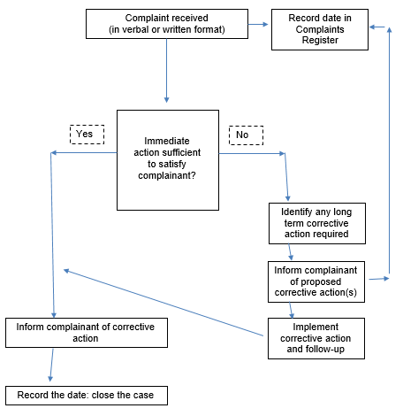

1. Public Complaints Form

|  |  |  |  |
| --- | --- | --- | --- |
| **PUBLIC COMPLAINTS FORM** | | | |
| **Full Name** |  | | |
| **Contact Information**  (Please indicate how you wish to be contacted: post, phone, email etc. and provide details) | 🗌 | By post: Please provide postal address: | |
|  |  | |
|  |  | |
|  |  | |
| 🗌 | By telephone: |  |
| 🗌 | By email: |  |
|  |  |  |  |
| **Preferred language for communication** |  | | |
|  |  |  | |
| **Description of incident or complaint** | | What happened? Where did it happen? Who did it happen to? What is the result of the problem? (Describe below) | |
|  | | | |
| **Date of incident/complaint** | | | |
| 🗌 | | One time incident/complaint (date ______________) | |
| 🗌 | | Happened more than once (how many times ______________) | |
| 🗌 | | Ongoing (currently experiencing problem) | |
|  |  |  | |
| **What would you like to see happen to resolve the problem?** | | | |
|  | | | |
|  | | | |
| **Signature** |  |  | |
| **Date** |  |  | |
|  |  |  | |
| **Please return this form to:** |  | (Company contact details) | |

1. Internal Complaints Management Form

|  |  |  |  |  |
| --- | --- | --- | --- | --- |
| **Internal Complaints Management Form** | | | | |
| **Date received** |  | | **Registration number** |  |
| **Name of Complainant** |  | | **Contact details given** |  |
|  | | | | |
| **Description of incident/**  **complaint** |  | | | |
| **Recommended for further investigation?** | 🗌 | Yes | | |
| 🗌 | No | | |
| **Justification** |  | | | |
| **Results of investigation** |  | | | |
| **Recommended mitigation** |  | | | |
| **Coordination Result** |  | | | |
| **Responsible Manager Signature:** |  | | | |