

**GUIDE FOR CONTENT OF ESIA**

**2014-11-17**

DOCUMENT CONTROL

|  |  |  |  |
| --- | --- | --- | --- |
| **Reference No.** | Form A11 | | |
| **Document Title** | Guide for content of ESIA | | |
| **Document Author** | M/S Grontmij | | |
| **Reviewed by** | Management | | |
| **Approved By** | Management | | |
| **Document Version** | 2 | **Document Status** | FINAL |
| **Date Released** | 2014-11-17 | | |
| **File Name** | 20141117_GuideContentESIA.docx | | |

DOCUMENT CHANGE HISTORY

|  |  |  |  |
| --- | --- | --- | --- |
| **Version** | **Date** | **Author** | **Description** |
| **1** | 2014-11-17 | M/S Grontmij | Initial release |
| **1.1** | 2023-03-30 | Anselm Olweny | Updated ERA Logo  Inserted Document Control Page |

1. **Cover page**

*Including logo, project title, name of developer, name of consultant, date of original and date of revised versions*

1. **Table of Contents**
2. **Non-Technical Summary**

*Should concisely discuss significant findings and recommended actions in appropriate and understandable lay language*

1. **Background**

2.1 Project justification and purpose

2.2 Project location

*Should include maps showing project site and area of influence*

2.3 Project description and associated activities, detailing the operation modes

*Describing the project context (geographic, ecological, social, health and temporal) as well as additional / associated project components, such as transmission lines, access roads and water supply).*

*Should also describe facilities and activities by third parties that are essential for successful operation of the project.*

1. **Environmental policy, legislative and Institutional framework**

*Presents the Ugandan policy, legal and administrative framework. Also presents obligations to international environmental and social treaties, agreements and conventions, the international standards applied to the project, other priorities and objectives for E&S performance identified by the buyer / project sponsor. Explains environmental and social requirements of the project investors.*

1. **Approach and Methodology**

*This Chapter must set out the approach and methodology used in the ESIA and how the data and information collected has been incorporated in the findings and recommendations.*

4.1 General Approach

*For example including flow charts depicting how the ESIA has been developed*

4.2 Methodology

*Describe the methodology used for data gathering, including the scientific approach for the baseline studies, for example sampling methods, instrumentation etc.*

*Describe the methodology used to categorize the significance of the environmental and social impacts identified (e.g. into high, medium and low risks).*

4.3 ESIA Team

*Briefly outline how the ESIA work was organised, the names of the team members, their roles and their qualifications.*

4.4 Assumptions, uncertainties and constraints

*Identify any information gaps and/or limitations to the available data.*

4.5 Stakeholder consultation

*Describe the stakeholder consultation process and the results. This may be presented as follows (extract from the ERA template for a Stakeholder Engagement Plan):*

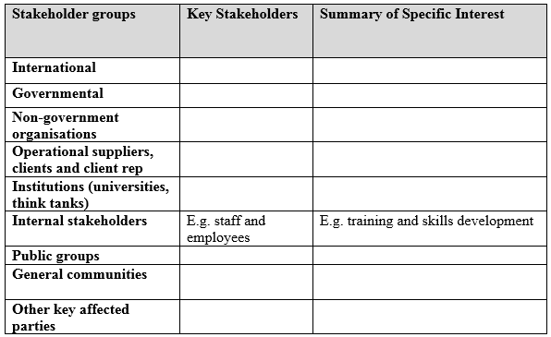

1. **Environmental and Social Baseline Study**

*Defines the study area delineated for the boundaries of the baseline study. Describes relevant physical, biological, socioeconomic, health and labour conditions, including any changes anticipated before the project start.*

*Considers current and planned development activities within the project area but not directly connected to the project. Indicates accuracy, reliability and sources of the data used.*

1. **Analysis of Alternatives**

*Analysis of alternatives: comparing reasonable alternatives to the proposed project technology, design, and operation in terms of their potential E&S impacts, the feasibility of mitigating these impacts, etc. The alternatives should match the alternative designs presented in the Feasibility Study. Include technical drawings, maps etc. of alternative designs.*

*Provide the criteria for the assessment and identification of the best design option available. Identify and provide justification for the best design option.*

1. **Impact Identification and Evaluation**

*Predicts and assesses the project’s likely positive and negative impacts, in quantitative terms to the extent possible. Identifies mitigation measures for the negative impacts, and any residual negative impacts that cannot be mitigated.*

*Identifies and estimates the extent and quality of the available data, key data gaps, and uncertainties associated with predictions, and specified topics that do not require further attention. Evaluates impacts and risks from associated facilities and third party activities.*

*Examines global, trans-boundary, and cumulative effects as appropriate.*

1. **Mitigation/optimisation Measures and Residual Impacts**

*Consists of the set of mitigation and management measures to be taken during implementation of the project to avoid, reduce, mitigate or remedy for adverse social and environmental impacts. These should be prioritised on the basis of an assessment of their significance.*

1. **Environmental and Social Management Programme**

*Organises the mitigation and optimization measures identified in chapter 8 into a programme of overall activities.*

*This may be made more operational through the development of specific action plans.*

*The ESMP may be a multiple of other plans, for example Stakeholder Engagement Plan, Resettlement Action Plan etc.*

*The ESMP may be structured as follows:*

|  |  |  |  |  |  |  |
| --- | --- | --- | --- | --- | --- | --- |
| Issues/aspects | Location | Mitigation measure | Key verifiable indicator | Person responsible | Remarks | Cost (USD) |
| Construction |  |  |  |  |  |  |
| 1. |  |  |  |  |  |  |
| 2. |  |  |  |  |  |  |
| Etc. |  |  |  |  |  |  |
|  |  |  |  |  |  |  |
| Operation |  |  |  |  |  |  |
| 1. |  |  |  |  |  |  |
| 2. |  |  |  |  |  |  |
| Etc. |  |  |  |  |  |  |

1. **MONITORING, EVALUATION AND REPORTING**

*Outline the monitoring, evaluation and reporting measures to be put in place to assess the effectiveness of the mitigation measures. Describe who will be responsible for their implementation, and whether a management system will be put in place.*

1. **Conclusion and Recommendations**

*This section must present a clear statement of the conclusions and recommendations on actions to be taken to ensure that environmental issues are adequately addressed in subsequent project preparation, implementation, monitoring and evaluation phases.*

1. **Appendices**

12.1 References Used

12.2 Technical Appendices

* Records of stakeholder engagement.
* List of stakeholders consulted or engaged. (Record of interagency and consultation meetings. Records of any other means of obtain the views of affected groups, such as surveys.)
* Terms of Reference.
* Other technical information and data, as required.
* List of ESIA report preparers – individuals and organizations
* References – written materials used in the study preparation – to be listed as follows: *Author, (year), reference title, journal or publisher, page number*
* Associated reports, audits and plans (e.g. resettlement action plan or indigenous peoples/natural resource dependent community plan, community health plan).
* Action plan describing actions necessary to implement the various sets of mitigation measures, prioritise these actions, timeline for implementation, schedule for communicating with the affected communities