

**GUIDE FOR CONTENT OF A PRE-FEASIBILITY STUDY REPORT FOR GENERATION PROJECTS**

**2014-10-10**

**Revised: 2014-11-14**

DOCUMENT CONTROL

|  |  |  |  |
| --- | --- | --- | --- |
| **Reference No.** | Form A1 | | |
| **Document Title** | Guide for content of a pre-feasibility study report for generation projects | | |
| **Document Author** | M/S Grontmij | | |
| **Reviewed by** | Management | | |
| **Approved By** | Management | | |
| **Document Version** | 2 | **Document Status** | FINAL |
| **Date Released** | 2014-11-21 | | |
| **File Name** | 20141121_GuideContentPre-feasibilityStudyReportGeneration.docx | | |

DOCUMENT CHANGE HISTORY

|  |  |  |  |
| --- | --- | --- | --- |
| **Version** | **Date** | **Author** | **Description** |
| **1** | 2014-11-21 | M/S Grontmij | Initial release |
| **1.1** | 2023-03-30 | Anselm Olweny | Updated ERA Logo  Inserted Document Control Page |

**TABLE OF CONTENTS**

1. Introduction
2. Description of Project Area
3. Technical Parameters
4. Environmental and Social Parameters
5. Financial and Economic Parameters
6. Stakeholders
7. Risks and Barriers to Project
8. Annexes
9. **INTRODUCTION**

*(Type of project, e.g. hydropower, bagasse or biomass.*

*Developer)*

1. **DESCRIPTION OF PROJECT AREA**
   1. Project location with coordinates and relevant site maps.
   2. Physical & Salient features of the project site

*(Hydropower: Rivers, escarpments, aqueducts, etc.*

*Bagasse: Sugar factory description*

*Biomass: Type of fuel/s, etc.)*

* 1. If hydropower: Other hydropower plants on the river system

*(Existing, planned, under construction)*

1. **TECHNICAL PARAMETERS**
   1. Technical description

*(Hydropower: Type of plant, size in MW, water flow, head, etc.*

*Bagasse: Size in MW, etc.*

*Biomass: Types of fuel/s, fuel supply, size in MW, etc.)*

* 1. Power evacuation

*(Length of line, and where it will connect to grid)*

1. **ENVIRONMENTAL AND SOCIAL PARAMETERS**
   1. Environmental and Social Scoping Study

*(The format below follows NEMA’s specification for the content of the Environmental Scoping Study. According to the Guidelines for EIA in Uganda (1997), NEMA shall approve the Scoping Study and Terms of Reference for the Environmental Impact Assessment. This section may be extracted as a stand-alone document and submitted to NEMA for approval, together with the Terms of Reference. ERA recommends that the Scoping Study and Terms of Reference are submitted together with the Notice of Intended Application for ERA’s comment, before they are submitted to NEMA. Annex 2 presents the environmental approval process in Uganda. Most energy projects enter at the E.I.S Study phase).*

* + - Cover page: logo, name of developer, name of consultant, date;
    - Executive summary;
    - Description of the project under consideration and its alternatives;
    - Applicable environmental legislation and institutional framework;
    - Key stakeholders and their concerns;
    - Key environmental and social aspects to be addressed in the Environmental and Social Impact Assessment (ESIA);

*(for example in case of land acquisition – who uses the land, will people be physically or economically displaced, and how will the project impact wildlife and protected areas, and will there be environmental pollution?)*

* + - Scope of the environmental and social baseline and areas of project influence;
    - Recommendations on specific impact identification and evaluation methodologies;
    - Time frames and resources needed to carry out the ESIA;
    - Technical appendices;
    - Stakeholder engagement methodology;
    - List of stakeholders/people and institutions consulted (including contact details);
    - Records of stakeholder engagement;
    - List of documents consulted;
    - List of tasks undertaken by the consultant.
  1. Terms of Reference for ESIA
     + Background
     + Objective
     + Results of scoping findings
     + Scope of work
     + Methodology
     + Time frame/ Work Schedule
     + Outputs
     + EIA Experts

1. **FINANCIAL AND ECONOMIC PARAMETERS**

*(Preliminary cost/benefit analysis)*

1. **STAKEHOLDERS**
   1. List of Stakeholders
   2. Permit Requirements
   3. Contacts made
2. **RISKS AND BARRIERS TO PROJECT**
3. **ANNEXES**

**Annex 1. Photo Gallery of Site Visits**

*(The developer should list and include photographs from site visits and other activities carried out during this period, as shown in the annexed table below).*

|  |  |  |  |
| --- | --- | --- | --- |
| **Table: Photo List** | | | |
| **No.** | **Description** | **Location\*** | **Date** |
|  |  |  |  |
|  |  |  |  |
|  |  |  |  |
|  |  |  |  |
|  |  |  |  |
|  |  |  |  |
|  |  |  |  |
|  |  |  |  |
|  |  |  |  |

*\* Please indicate GPS coordinates*

**Annex 2. The Basic Components of the EIA Process**

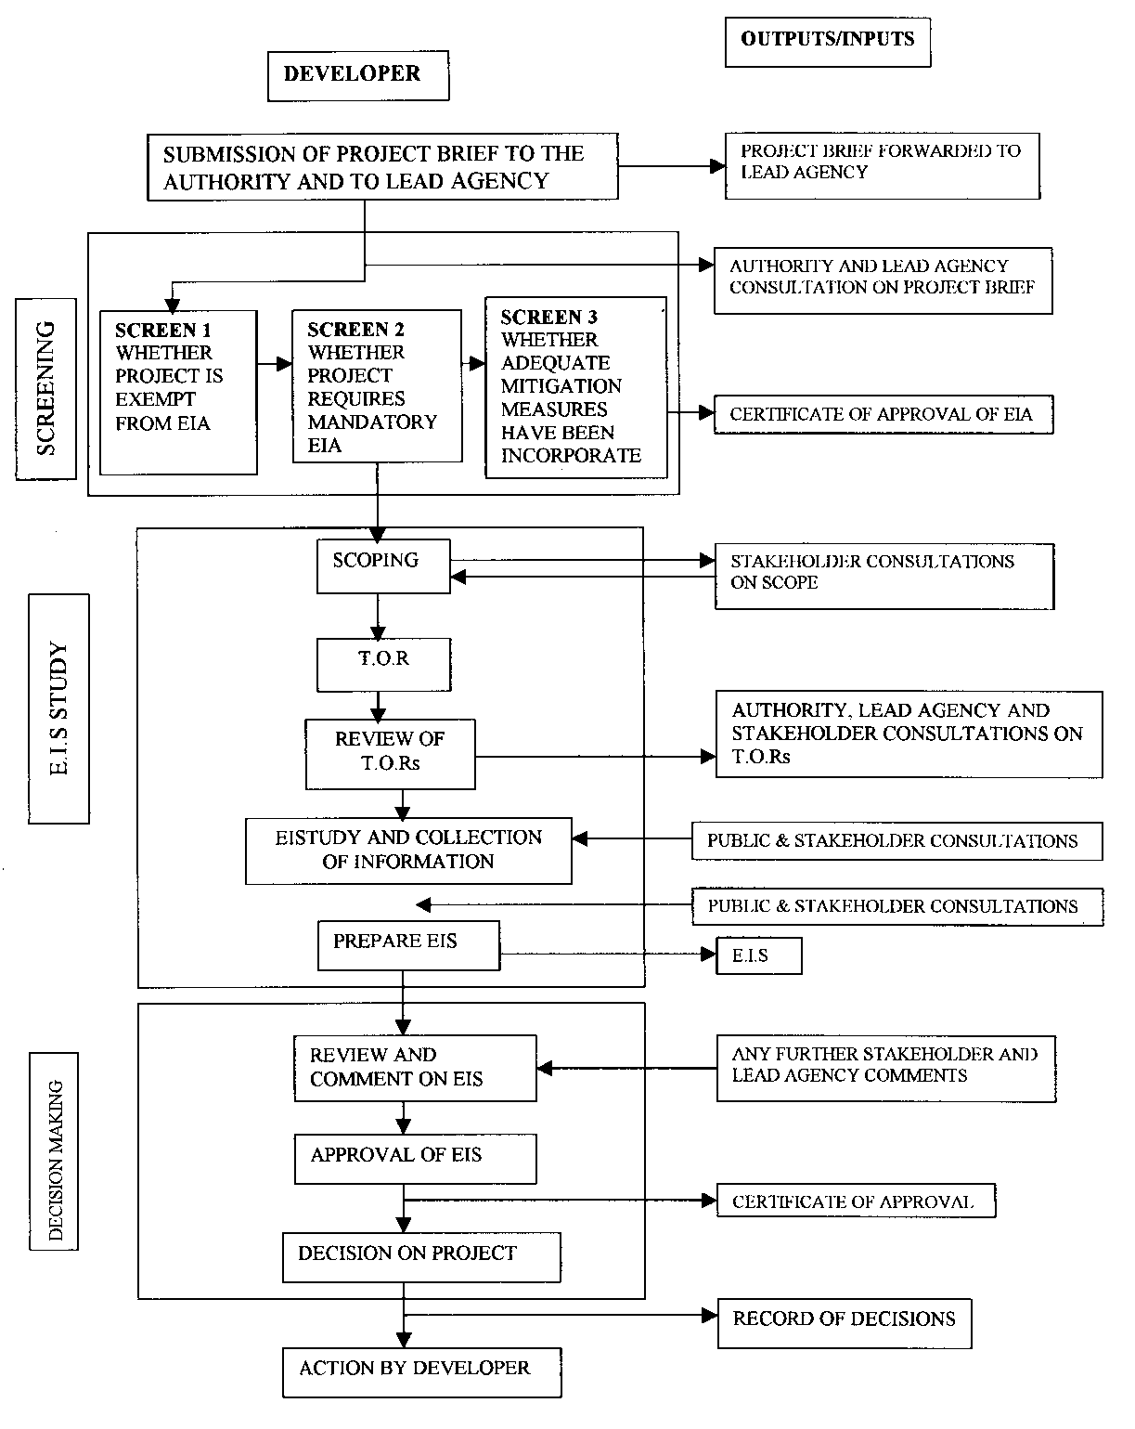

*Source: Ministry of Energy and Minerals Development, EIA Sector Guidelines for the Energy Sector in Uganda, Revised Draft, March 2013*